Experiment -12
NAME: A. Vikranth Reddy
Rg No:192424193
Course Code: DSA0406
Course Name: Fundamentals of Data Science for Data Processing
12. Scenario: You are working on a data analysis project that involves analyzing the monthly temperature and rainfall data for a city. You have a dataset containing the monthly temperature and rainfall values for each month of a year. Your task is to develop a Python program that generates line plots and scatter plots to visualize the temperature and rainfall data.
Question:
- Develop a Python program to create a line plot of the monthly temperature data.
- 2: Develop a Python program to create a scatter plot of the monthly rainfall data.
Code
1. Line Plot of Monthly Temperature Data
import matplotlib.pyplot as plt
months = ["Jan","Feb","Mar","Apr","May","Jun","Jul","Aug","Sep","Oct","Nov","Dec"]
temperature = [22, 24, 28, 32, 35, 34, 33, 31, 30, 28, 25, 23]
plt.plot(months, temperature, marker='o')
plt.title("Monthly Temperature Line Plot")
plt.xlabel("Months")
plt.ylabel("Temperature (°C)")
plt.grid(True)
plt.show()
Output:

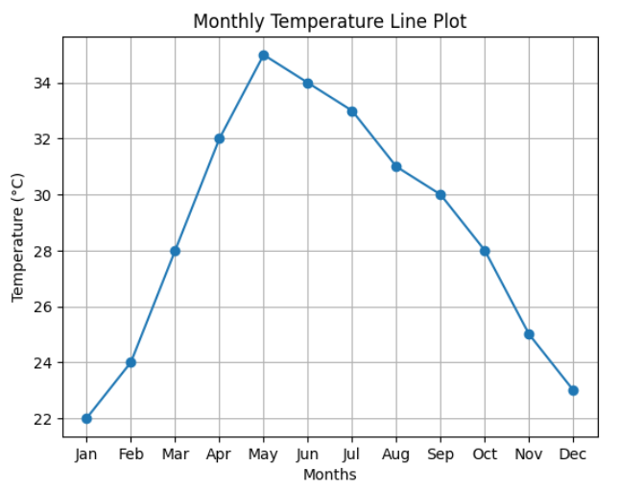
2.Scatter Plot of Monthly Rainfall Data
import matplotlib.pyplot as plt
months = ["Jan","Feb","Mar","Apr","May","Jun","Jul","Aug","Sep","Oct","Nov","Dec"]
rainfall = [15, 20, 25, 40, 60, 120, 150, 140, 100, 70, 30, 20]
plt.scatter(months, rainfall)
plt.title("Monthly Rainfall Scatter Plot")
plt.xlabel("Months")
plt.ylabel("Rainfall (mm)")
plt.grid(True)
plt.show()

Output:
